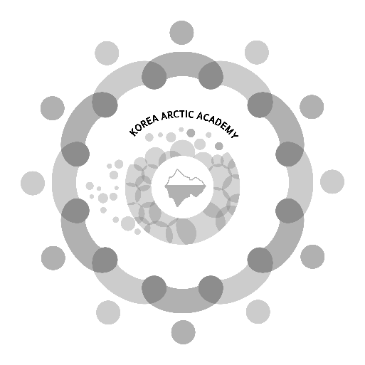
The Korea Arctic Academy, hosted by the Korean Ministry of Oceans & Fisheries and co-organized by the Korea Maritime Institute (KMI), is an initiative to facilitate exchanges between students from both the Arctic region and Korea to develop and share a common Arctic vision.
It aims to spread knowledge on sustainable Arctic development and ocean management and promote understanding of the Arctic indigenous peoples.
The Korea Maritime Institute serves as a Secretariat of the Academy. The program of the Korea Arctic Academy usually consists of lectures on Arctic issues, given by international or Korean experts, and field trips to Arctic-related organizations, research institutions, and industrial sites in Korea.
Due to the extraordinary situation caused by the outbreak of the COVID-19 pandemic, we have made decision to call off the physical gathering of the Korea Arctic Academy in Busan and replace it with an online course for 1 week.
This year as the COVID-19 pandemic situation has stabilized compared to the previous year, we intend to provide courses to Korean and UArctic students with real-time online lectures on Arctic and conduct real-time conferences to strengthen interactive communication between Korean and UArctic students. We also would like to provide recorded lecture videos for students who will not be able to attend the real-time lectures due to the time difference.
And finally, we are planning to invite and provide travel grants to 3 outstanding students to the 2023 Arctic Partnership Week in Busan in December 2023. The Arctic Partnership Week has been organized annually since 2016. During its existence, the event has focused on Arctic policy, science, technology, shipping, energy, and resources.
The 9th Korea Arctic Academy will begin on JULY 7 and end on JULY 14.
Please submit a CV (should include email address, study program, affiliation, address to receive Welcome kits and Certificate of Completion, phone number) and a motivation letter (approx. 600 words/1 page) in one file to isabelle.guissard@uit.no or jwyoo21@kmi.re.kr by 30 JUNE 2023.
Requirements to applicants
-The student should have finished their second year of Bachelor’s study
-The student is motivated to actively participate and to enhance understanding of the Arctic and Korea

Course framework at a glance:
Date | - OT: 7th July  - Lectures: 10th July – 12th July  - Online Workshop: 13th July  - Online Conference1: 14th July  - Online Conference2: 14th July
Tuition | - FREE
Organizer | - Korea Maritime Institute  - UArctic
Course content/Topics | - Arctic Policy  - International Arctic Governance  - Korea Arctic Policy  - Climate Change in the Arctic  - Arctic Society and Indigenous Peoples  - Innovations in the Arctic  - Arctic Sustainable Economy
Level | - Introductory
Language | - English
Course Type | - Self-paced on your time
Course Format | - Online lectures  - Real-time conference1  - Real-time conference2  - Workshop
Course Completion Requirements | - Attending over 80% of online lectures  - Participating in the online conference at least once  - Completing Student Workshop  - Submitting a Final Paper
Reward | - Providing the travel grant to Korea for attending “2023 Arctic Partnership Week” in December to the 3 outstanding students
Note | - All students who complete the course will receive a KAA welcome Kit and a Certificate of Completion.

Main Programs:
OT | 7th July | Realtime Online | - Opening Address (KMI)  - Congratulatory Address (UArctic)  - Introduction (KMI)  - Introduction (Korea Arctic Academy)  - Close
Lectures | 10th~12th July | Realtime Online  Recorded video | - Arctic Policy&Governance  - Arctic Economy&Industry  - Arctic Indigenous people  - Arctic Science  - Climate Change in the Arctic
Workshop | 13th July | Realtime Online  Recorded video | - Presentations(students)
Arctic Connect | 14th July | Realtime Online  Recorded video | - Lecture1: Arctic Movie  - Lecture2: Arctic Documentation  - Lecture3: Arctic Food
Dialogue with UArctic Professors | 14th July | Realtime Online  Recorded video | - Introduction  - Introduction (UArctic)  - Lecture1 (UArctic Professor)  - Lecture2 (UArctic Professor)  - Q&A  - Close
Completion Ceremony | 14th July | Realtime Online  Recorded video | - Congratulatory Address (KMI)  - Congratulatory Address (UArctic)  - Announcement of outstanding students  - Awarding of Certificate

Lectures:
Date | Section | Subject | Speaker
10th | Introduction | Korea Arctic Academy | Min Su Kim, Deputy President of Ocean Economy Strategy Department, Korea Maritime Institute
10th | Arctic Policy | Canada’s Arctic Policy | Rouslan Kats, Counsellor of Head of Political, Economic and Public Affairs, Embassy of Canada to the Republic of Korea
10th | Arctic Policy | Iceland’s Arctic Policy | Pétur Ásgeirsson, Senior Arctic Official, Ministry for Foreign Affairs in Iceland
10th | Arctic Policy | Norway’s Arctic Policy | Frode Solberg, Ambassador of Embassy of Norway to Korea
10th | Arctic Policy | Korea’s Arctic Policy | Hong Young-ki, Ambassador for Arctic Affairs, Ministry of Foreign Affairs of Republic of Korea
11th | Arctic Policy | Finland’s Arctic Policy | Mika Ruotsalainen, Deputy Head of Mission of Embassy of Finland to Korea
11th | Arctic Policy | U.S. Arctic Policy | Evan Bloom, Senior Fellow, Wilson Center
11th | Future of the Arctic | Facilitating Sustainable Economic Development in the Arctic | Mads Qvist Frederiksen, Director of the Arctic Economic Council
11th | Future of the Arctic | International Arctic Scientific Cooperation | Hyung Chul Shin, Vice President, KOPRI
12th | Arctic Policy | Denmark’s Arctic Policy | Einar Jensen, Ambassador of Embassy of Denmark to Korea
12th | Arctic Policy | Sweden’s Arctic Policy | Jakob Hallgren, (Former) Ambassador of Embassy of Sweden to Korea
12th | Sustainable Arctic | Climate Change in the Arctic | Specialist of KoNAC(Korean Network for the Arctic Cooperation)
12th | Sustainable Arctic | Indigenous People | Dale Sambo, ICC

