“People in changing world”

22. – 26. March 2011 at Sámi University College, Diehtosiida, Guvodageaidnu- Kautokeino Norway (Preliminary program).

A course provided on master and PhD level by UArctic Thematic Network on Global Change in the Arctic on different aspects of using traditional knowledge in the rapid changing Arctic societies including the seminars, Sami Parliaments Seminar on Traditional Knowledge, Indigenous Traditional Knowledge and Academic Knowledge Building - What Indigenous Communities Wishes and What Academia Can Offer and UArctic EALÁT Institute Opening/ Prince Albert II Seminar: Ethics of Knowledge Development in cooperation with:

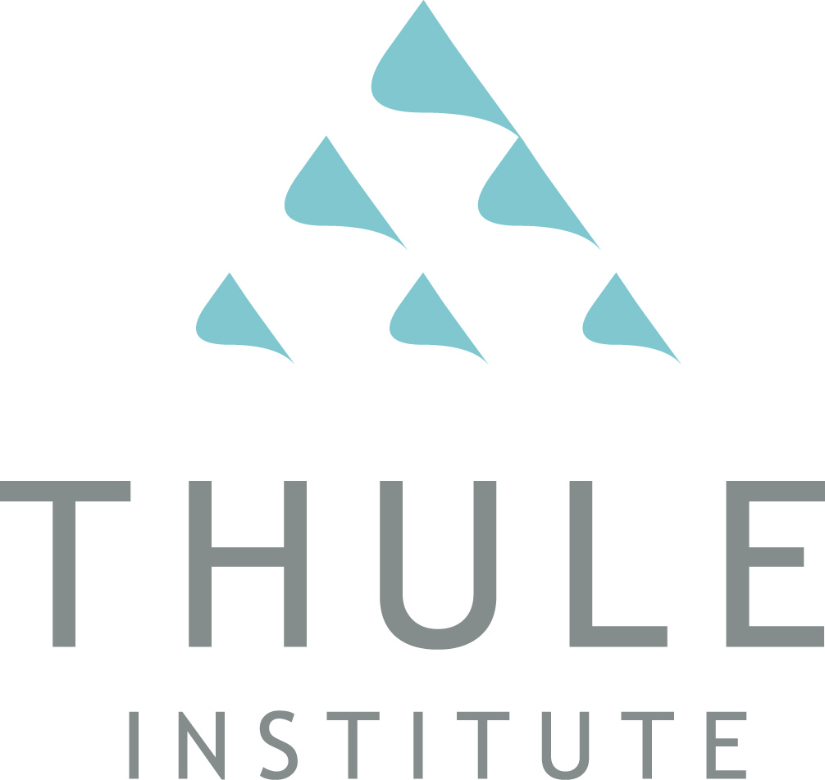
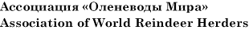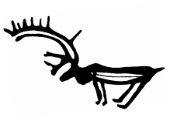UArctic EALÁT Institute

Participants: Master and PhD students, Rectors Forum participants, EALÀT Institute Guests, Sami Parliament TK Seminar participants, EALÀT Students, UArctic Rectors Students
Language will be translated from North Sami to English and Russian.

The PhD course is organised by Thematic Network on Global Change (http://www.uarctic.org/SingleArticle.aspx?m=174&amid=405) and funded by NorForsk Top-level Research Initiative “Effect studies and adaptation to climate change” as the first course organized by the Nordic Network “People and Ecosystems in a changing world”. The participation will give PhD students certificates for gaining credits in their home organizations.

The PhD course consists of seminars and lecturers and student presentation. Each student must give a presentation in the seminar on Friday 26th related to use of traditional knowledge in according to agreements. The whole week of events is open for the PhD students.

If you want to register to the UArctic PhD course please contact Kirsi Latola, email: kirsi.latola@oulu.fi and for accommodation contact Elna Sara (email: elna.sara@reindeercentre.org). The deadline for registration is March 18th but please note that if you need an accommodation contact Elna as soon as possible. PhD students from Nordic countries can apply for travel grant and free accommodation, please contact Kirsi Latola on that.

PRELIMINARY PROGRAMME:

Tuesday 22nd

Sami parliaments seminar about traditional knowledge

09:00 PhD course students meet for planning, discussion and registration.

10:00 to 10:05 Yoik by Sara Marielle Gaup
10:05 to 10:10 Welcome by the Mayor of Kautokeino Municipality Klemet Erlend Heatta.
10:10 to 10:30 President Egil Olli, Sami Parliament in Norway: Status and challenges connected to traditional knowledge in Sapmi.
10:30 to 10:50 President Ingrid Inga, Sami Parliament in Sweden and leader of SPR: Strategies and communication about traditional knowledge in Sweden.
10:50 to 11:00 Questions
11:00 to 11:20 Coffee Break
11:20:11:40 Leader Valentina Sovkina, Kola Sámi Sobbar: The Sami People in Russia and the situation of the traditional knowledge
11:40 to 12:00. President Klemetti Näkkäläjärvi, Sami Parliament in Finland: Obligations under the Convention on Biological Diversity, Article 8 (j) and implementation of traditional knowledge in Sapmi.
12:00 to 12:20 State Secretary Raimo Valle, Ministry of Government Administration and Reform Government: Sami policy in Norway to strengthen the Sami traditional knowledge.
12:20 to 12:30 Questions / Comments
12:30 to 13:30 Lunch, Diehtosiida
13:30 to 14:00 Project leader Dr. Jelena Porsanger Sámi allaskuvla / Sámi University College Árbediehtu pilot project: Traditional knowledge for sustainable communities and management
14:00 -14:20 Per Mikael Utsi, board member of the Sami Parliament in Sweden. Reindeer herder and Biologist and
Håkan Tunón, program chef NAPTEK / Centre for Biological Diversity
Traditional knowledge and practices within the Sami culture.

1420 to 14:30 Questions
14:30 to 14:50 Coffee Break
14:50 to 15:10 Dr. Elina Helander-Renvall, Arctic Centre, University of Lapland: Status and trends of traditional knowledge in the Arctic.
15:20 to 15:40 Head for Arctic Environmental Department Gunn-Britt Retter, Saami Council: Climate change and indigenous adaptation strategies, the use of traditional knowledge.

15:30 to 15.50 Håkan Tunón, researcher, program chef NAPTEK /Swedish Biodiversity Centre – a National Programme for Local and Traditional Knowledge related to Conservation and Sustainable Use of Biological Diversity: Traditional knowledge and sustainable future. NAPTEK`s experiences.
15:50 to 16:00 Questions
16:00 to 16:10 A summary of the day
by / Senior Advisor Jon Petter Gintal, the Sami Parliament, Dr. Jelena Porsanger Sámi allaskuvla / Sámi University College

Wednesday 23rd

Indigenous Traditional Knowledge and Academic Knowledge Building - What Indigenous Communities Wishes and What Academia Can Offer,Theme focus: Indigenous and non indigenous societies in the North; Challenges for research and Education within UArctic

09:30 to 09:35 Yoik by Niko Valkeapää

09:35-09:45 President Egil Olli, Same Parliament in Norway
Rector Steinar Pedersen, Sámi allaskuvla/Sámi University College

09:45-10:10 Indicators of traditional knowledge, Working Program of Convention of Biological Diversity (CBD) article 8 (j) about traditional knowledge. Joji Carino, CBD Capacity Building Projec, Tebtebba, Indigenous Peoples' International Centre for Policy Research and Education:
10:10-10:25 Indigenous peoples rights and traditional knowledge related to the international regime on gene resourses , CBD-ABS Dr. Mattias Åhrèn, University of Tromsø (15 min)

10:25-10:40 Break

10:40-10.50 Introduction to the panel discussion Professor Ole Henrik Magga, Sámi allaskuvla/Sámi University College

10:55-12:10 Chair: Janne Hansen, GÁLDU, Resource Centre for Rights of Indigenous Peoples and Vice chair: Jim McDonald, UNBC, Canada (Chair of Council of UArctic)
(Purpose is to engage whole auditorium in discussion with panelists)

Panel participants:

Douglas Nakashima, UNESCO (3min)
Gunn-Britt Retter, Saami Council (3min)
Mattias Åhrèn, University of Tromsø (3min)
Joji Carino, Tebtebba (3min)
Sigmund Grønnmo, rector, University of Bergen, Norway (3min)

12:10-12.25 Conclusion/ What have we learned/ Dr. Jelena Porsanger, Sámi allaskuvla/Sámi University College

12:30-13:30 Lunch at Diehtosiida

13:30-14:15 Director, Professor Dr Douglas Nakashima, UNESCO. The importance of traditional knowledge and UNESCO in today`s changing world.

14:15- 14:35 Protection of traditional knowledge ongoing work to establish new rules in WIPO
Lawmaker Magnus Greaker, Ministry of Justice and the Police, Norway

14:35-14:45 Questions

14:45-15:00 Break

15:00-1530 Future work on Convention of Biological Diversity and its implementation of article 8 (j)
Desk officer Börje Alriksson, Ministry of Environment, Sweden
Advisor Emine Isciel, Ministry of Environment, Norway

15:30- Closing session
1550- Film: “Traditional Fishing with a Seine Net in Guovdageaidnu”
By: Isak M. Hætta, Inger Anne Hætta, Liv Østmo, Nils John Porsanger
Length: 30 min. Language: Saami (simultaneous translation into English)

1600 PhD course student discussion meeting.
Location: Room:

20.00-22.00 Reception at Thon Hotel, Kautokeino,
Common mingle party for all participants: UArctic Rector’s/Student’s, UArctic EALÁT institute/seminar, and participants from The Norwegian Sami Parliament /Sametinget ,
Standing buffet arranged by Thon Hotel for UArctic leaders, UArctic rectors and reindeer herders and other invitees, local Sami cuisines. Cultural events

Thursday 24th of March 2011

HSH Prince Albert II Seminar: Ethics of Knowledge Development

0900 – 1000 Dr Marie Dr Marie Roue, Research Director at the French National Centre for Scientific Research (CNRS): Managing Biodiversity Issues of knowledge and power: The case of Traditional knowledge and Sami Snow how.
Location: room 01-087 Sullodat at 1- floor

10:50 All participants present in Diehtosiida ,
Location; RoomU1-080 Sáháskáidi, the main auditorium

10:55 Sami Parliament Presidents, Ministers and Governors arrive Diehtosiida

10: 55 HSH Prince Albert II enters Diehtosiida, lower ground level entrance, guided by sámi live joik (trad. singers) and sounds.

HSH Prince Albert II and his entourage undress outdoor clothing.
A special guardian will look after the clothes.

The Prince is guided by the hosts, to their respective seats. SEATING PLAN follows shortly

11:00 Sámi traditional joik with reindeer herder Mrs Marit Gaup Eira and
Professor Dr. Mr. Ole Henrik Magga.
Arranged by Assistant Professor Mrs May Britt Utsi (5 min).

11:05 Conveners: PhD student Ms. Anna Degteva and master of
Science student Ms Ravdna Biret Marja Eira

Welcome Mr. Barry Scherr, Chair of the Board of Governors of University of the UArctic, (3 min).

Welcome Rector Liisa Holmberg and Rector Steinar Pedersen, hosts of UArctic
Rectors’ Forum (5 min).

Welcome Secretary General and chair, Mr. Johan Mathis Turi, World Reindeer Herders Association, and International Centre of Reindeer Husbandry (5min)

Greetings President Mrs. Ingrid Inga, leader of the Swedish Sámi Parliamentary Council, on behalf of the Sámi parliaments of Finland, Norway and Sweden. (5 min)

Greetings Mr. Erik Solheim, Norwegian Minister of the Environment and International Development (10 min. )

Greetings President of Sámi Council, Mr. Olav Mathis Eira (3 min)

Greetings NFR ???

11:45 HSH Prince Albert II, Address to UArctic Rectors’ Forum and UArctic EALAT Institute

HSH Prince Albert II to officially:
- open the new UArctic Institute of Circumpolar Reindeer Husbandry: UArctic EALÁT Institute, and

- announce the UArctic EALAT Albert stipend program.

Indigenous female /male youth from different regions of the Circumpolar Arctic, Russia, Mongolia and Nordic countries will enter the stage, guided by Dr Mikhail Pogodaev, President of the Council of UArctic EALÁT Institute and Executive Chair of Association of World Reindeer Herders

12:05 - 13:00 Arctic Lavvo dialogue: “Ethics of knowledge development”

Conveners: . Ms Gunn Britt Retter, member of Sámi parliament in Norway, and Professor Mr. Robert Corell

Dialogue participants in the Lavvo:
o Mr. Erik Solheim, Norwegian Minister of the Environment and International Development
o Dr. Ms Sara Wright Cardinal, President, Aurora College, NWT, Canada
o Dr. Mr. Ole Henrik Magga, Professor, former chair of UN Permanent Forum for Indigenous Peoples
o Dr. Mikhail Pogodaev, Executive Chair of Association of World Reindeer Herders
o Ms. Helena Omma, Chair Sámi Youth organization in Sweden
o UArctic HSH Albert II EALÁT student (female)
o UArctic Rectors Forum student (female)
o Dr. Mr. Douglas Nakashima, Professor and director at UNESCO (United Nations Educational, Scientific and Cultural Organization)
o Dr. Mr. Nils Oskal, Professor at Sámi University College

12:55 - 13:15 Reindeer herders voice from the Russian Tundra, with
professional traditional singer from Eastern Siberia, Saina

13.30 -15:00 Lunch at Diehtosiida, for seminar participants, in the dining hall, at the lower ground floor level

1500 – 1700 The Arctic Lavvo Dialog continue on “Ethic of Knowledge development”:
Conveners Gunn Britt Retter and Robert Corell.

      - Professor Deborah H Oughton, Member of National Committee for Ethics in Science and Technology (NENT)

      - Olav Thon, Norwegian Industrial developer.

      - Professor Erik Reinert.

      - Prof. Dr of law. Vladimir Kryaskov, Russia, Russian view about TK and Arctic Indigenous Peoples.

      - President of Sami Nuorra Helene Omma

      - Dr Mathias Åhren, University of Tromsø, Self Governance of own knowledge.

      - Dr Nancy G Maynard, NASA, Experience from NASA Tribual College program

      - Reindeer Herders Olav Mathis Eira President Sami Counci

      - Phd student Ellen Inga Turi Experiences from the EALAT project

      - Phd student Anna Degteva. Experiences from the EALAT project

      - President of Norwegian Sami Reindeer Herders Association. Nils Henrik Sara

      - Concluding remarks reindeer herder Johan Mathis Turi and Associated Professor Asta Balto.

19:45 All guests are seated in Diehtosiida, dinner hall, awaiting HSH.

20:00-23:00 Royal Dinner at Diehtosiida.

Menu:
Food based on local ingredients, both traditional and modern style. Detailed menu and selection of vines etc. to follow shortly. We guarantee no pineapple or blue tuna.

Local food prepared by Kokkenes Mesterlaug i Finnmark - The Master Chefs’ Union in Finnmark, in with Thon.Cultural events.

Friday, March 25th:

HSH Prince Albert II Seminar: Ethics of Knowledge Development, continue

0900 Professor Erik Reinert, Reindeer husbandry and the ethical dilemma of using right knowledge in economic development (TBC)

0930 Professor Tor Benjaminsen. "Pastoralism and the State in Africa: What are the parallels to Finnmark"

1000 Professor, Vladimir Khyraskov, The Russian laws and Arctic Indigenous Peoples Traditional Knowledge.

1030 Professor Deborah H Oughton, Member of National Committee for Ethics in Science and Technology (NENT). NENTs work with development of guideline for use of traditional knowledge in science in Norway (TBC)

1100 Professor Ludmila Gashilova, Hertzen Inst. Hertzen University St. Petersburg, The ethical dilemma of bringing Arctic Indigenous Students to St Peterburg for higher education 80 years experience!!

1130 Mathias Åhren: Self governance of own knowledge.

1200- 1600 PhD course students presentation, dialog and concluding remarks

Saturday 26th

1100- 1800 at LES building

Joint meeting with Sami and Russian Reindeer herders about change in reindeer herding pastures.

Bidus and celebration of cooperation.

